Create an Account in AWS

During account creation it will ask Account details and it will deduct 2 rs

for confirmation and again they will return back our amount.

Login in to AWS Account

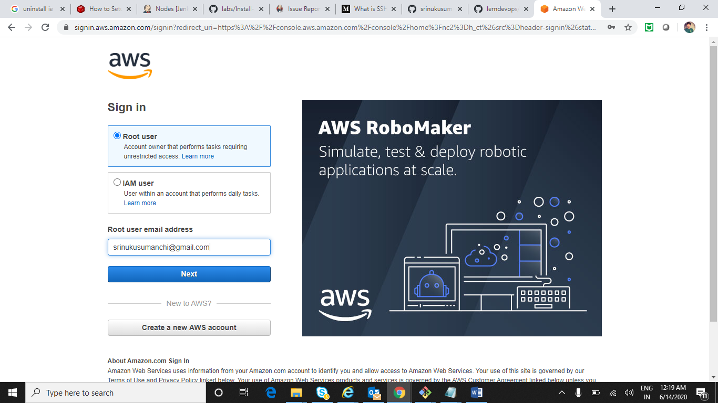 Enter password

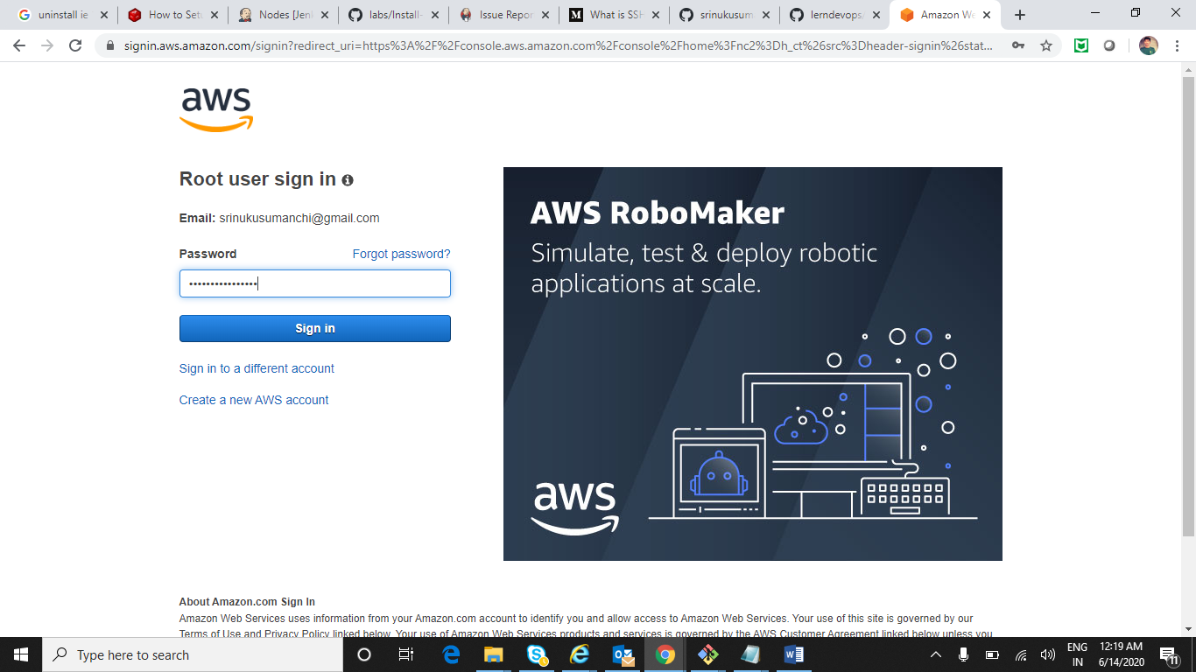

Click on EC2-> Elastic compute cloud

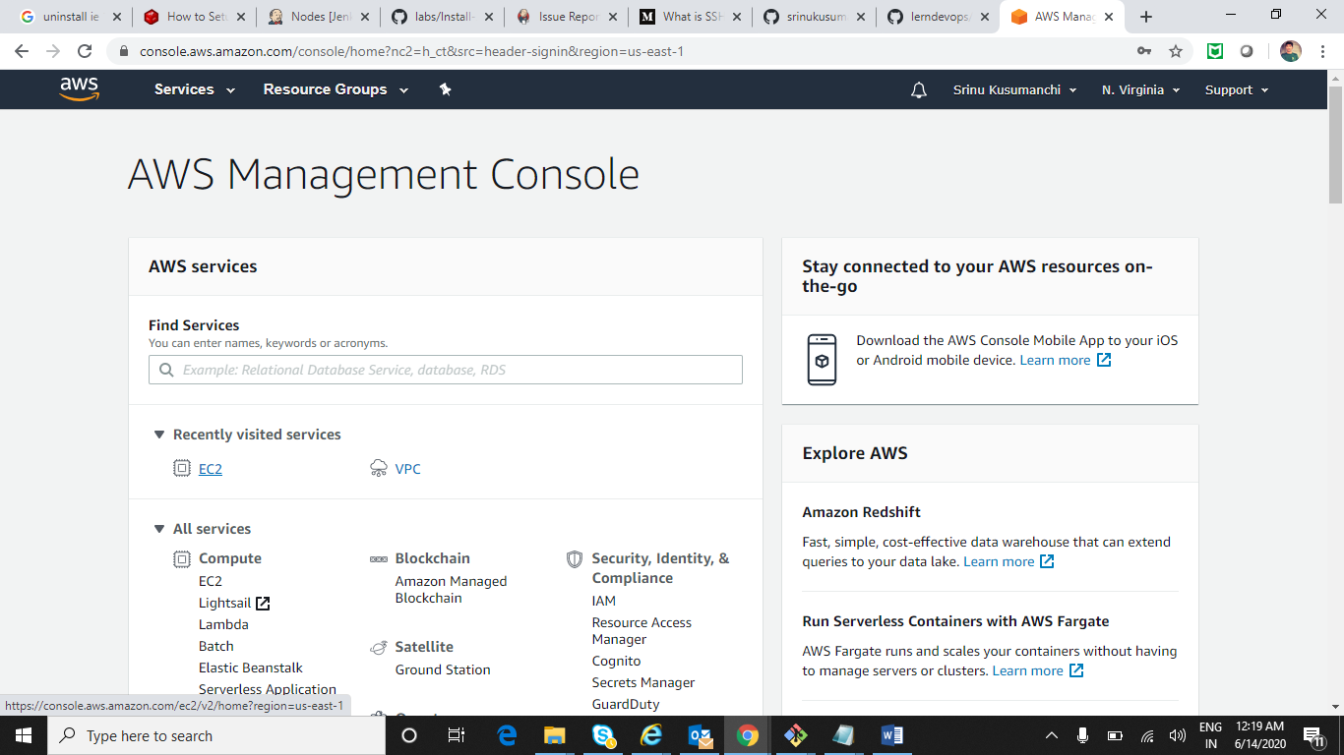

Click on Launch Instance

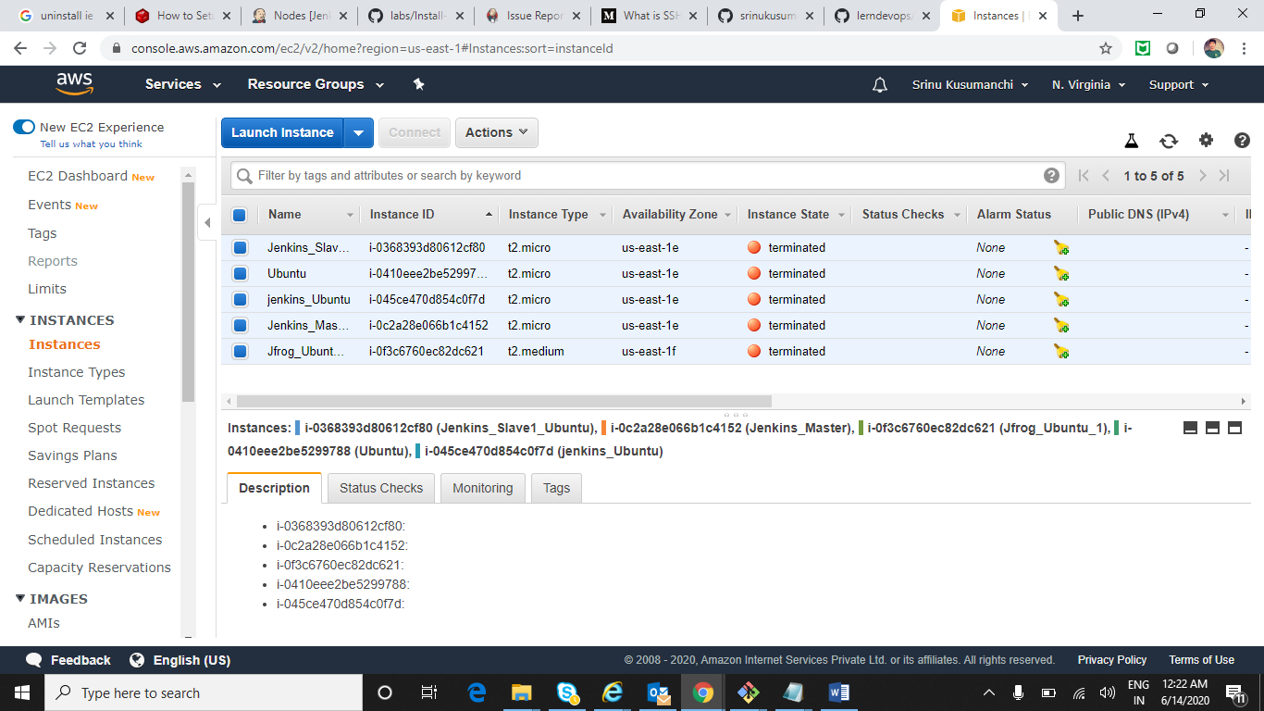

In Search type your required OS eg:-Ubuntu (Hear I am going with Ubuntu Server 16.04)

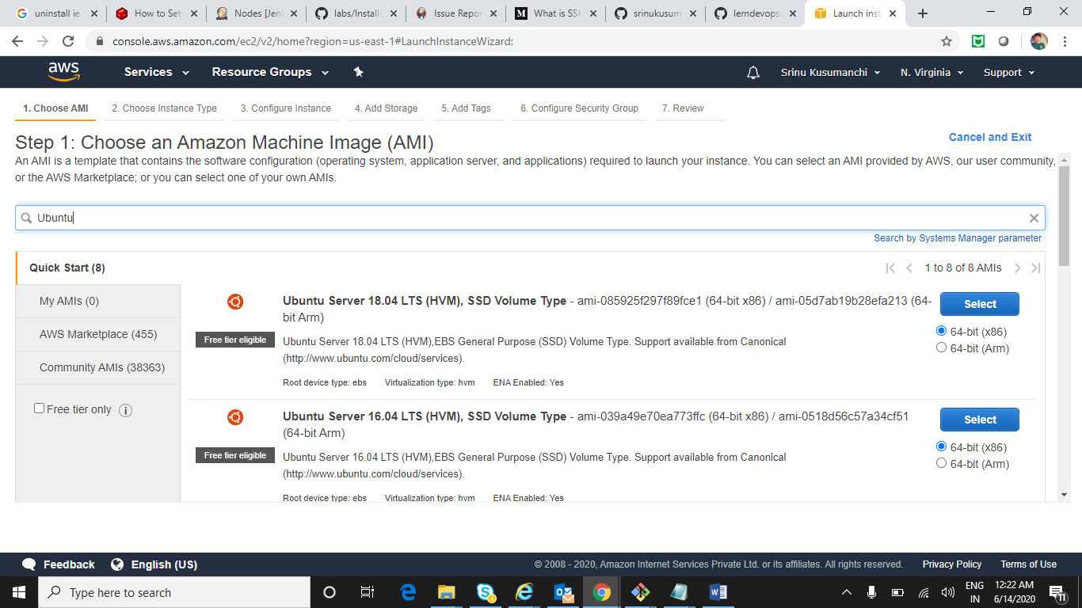

Default it select t2.micro which is free and click on Next Configure Instance details

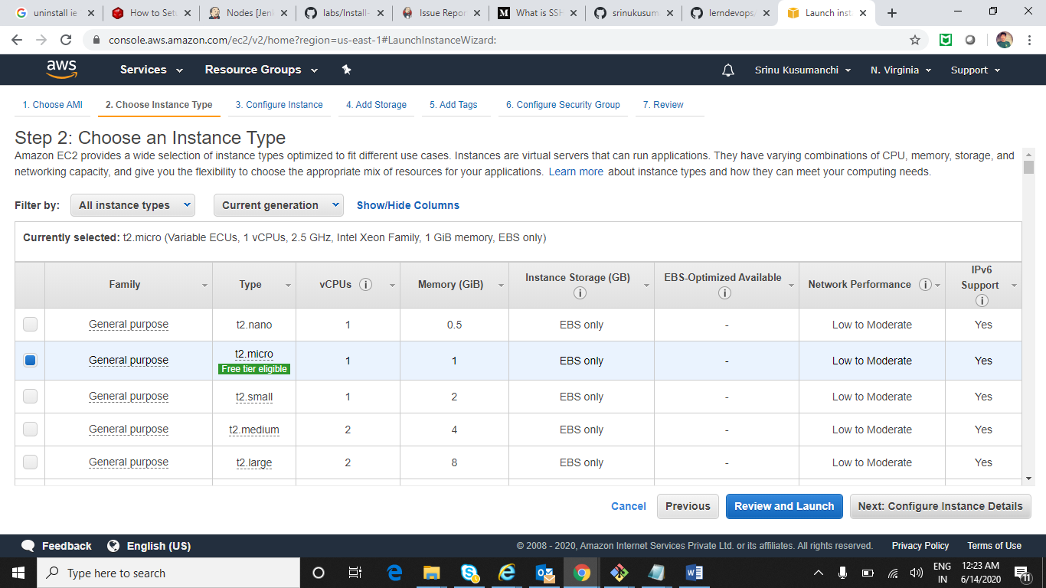

It will show all Instance Details and click on Next:Add Storage

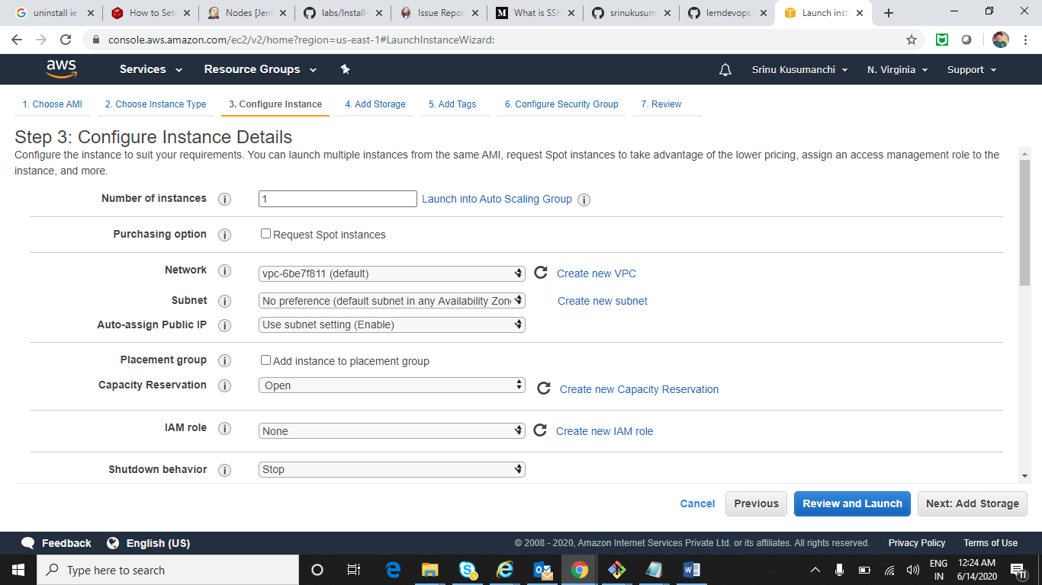

We can add additional storage if we want and click on Add Tags

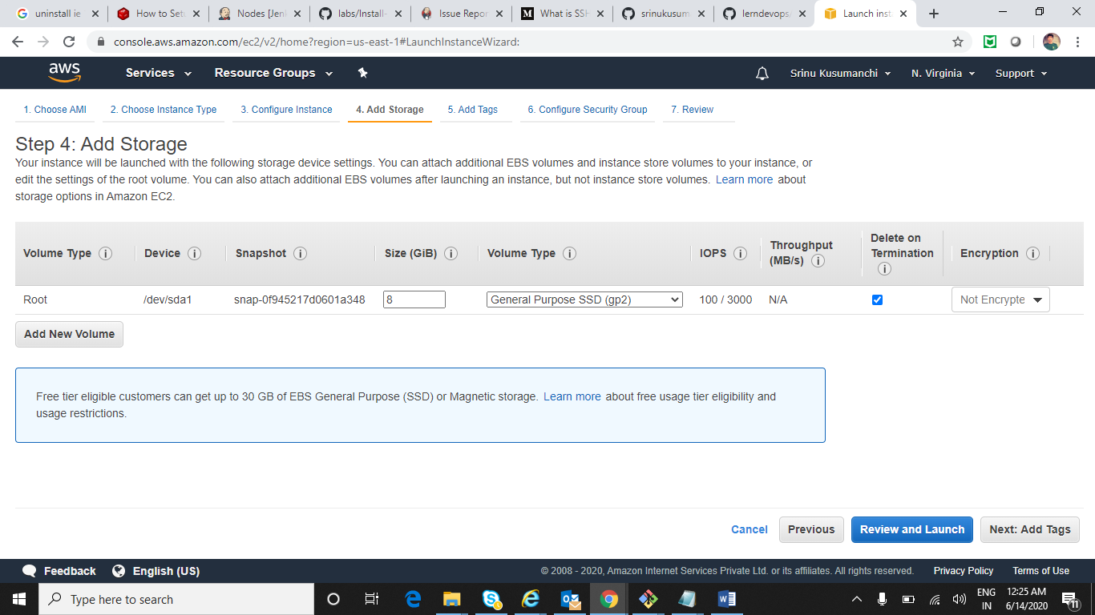

Add Tags and click on Configure Security Group

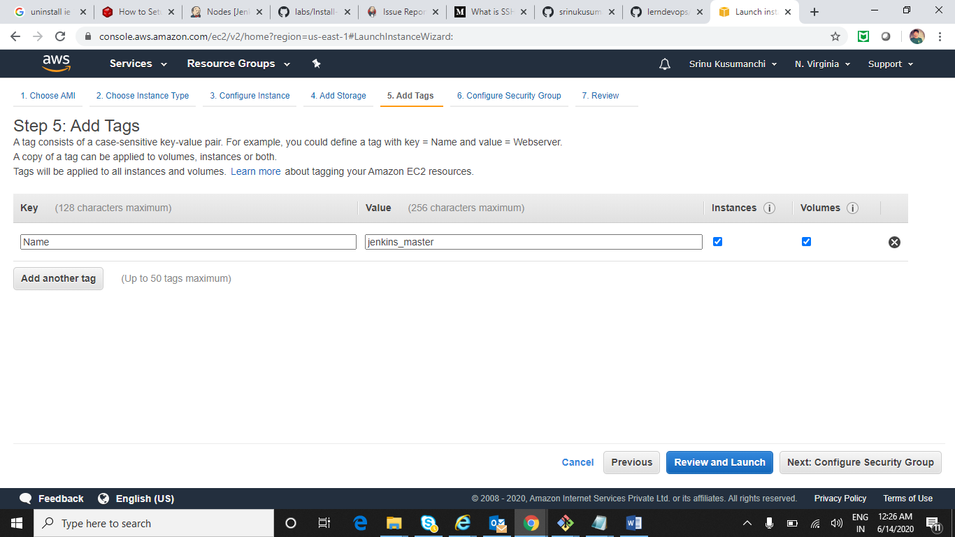

Select Source Anywhere which means we can access ip from any machine and click on Review and launch button

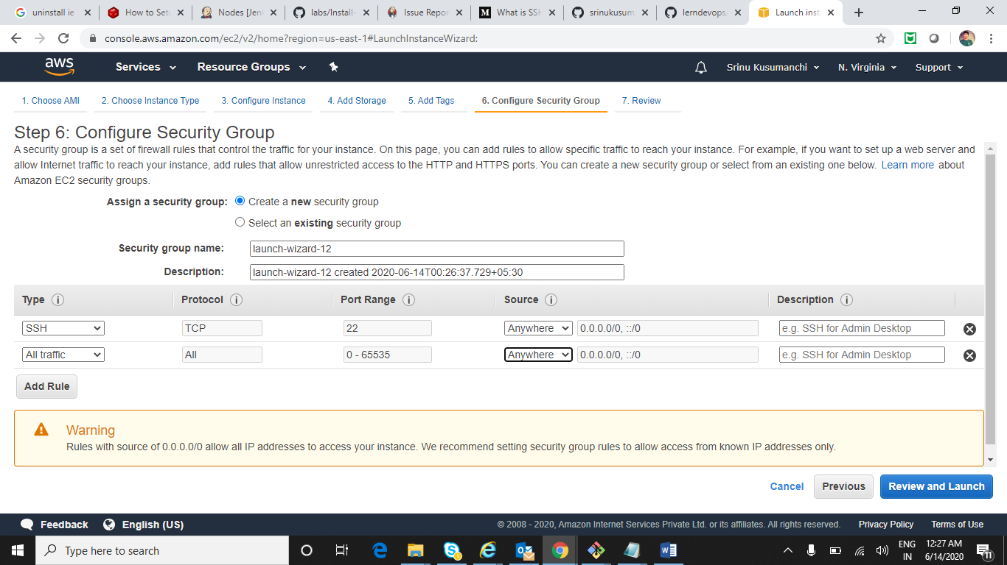

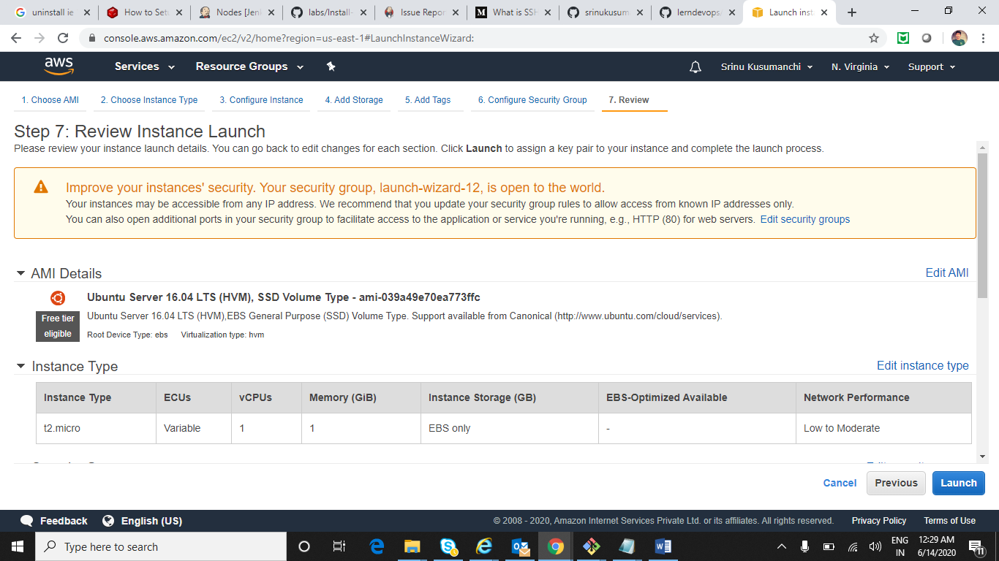

Click on launch

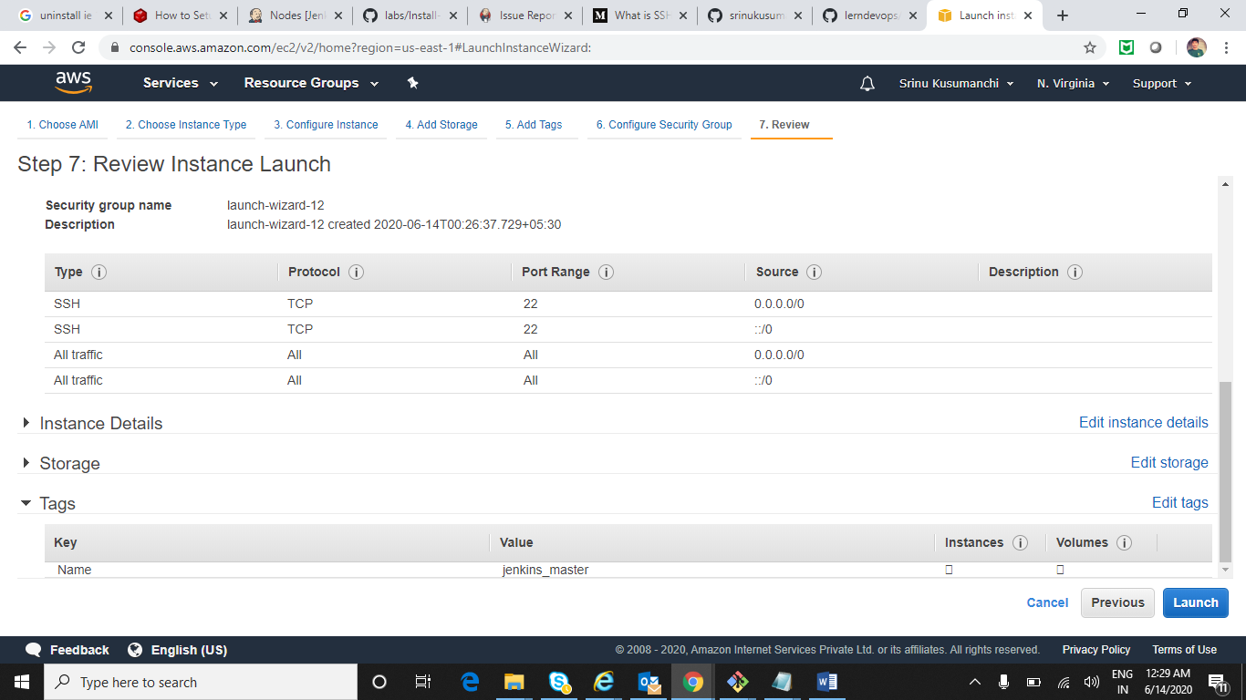

Select either existing key pair or create new key pair which will download .pem file to our machine and after that click on launch instances

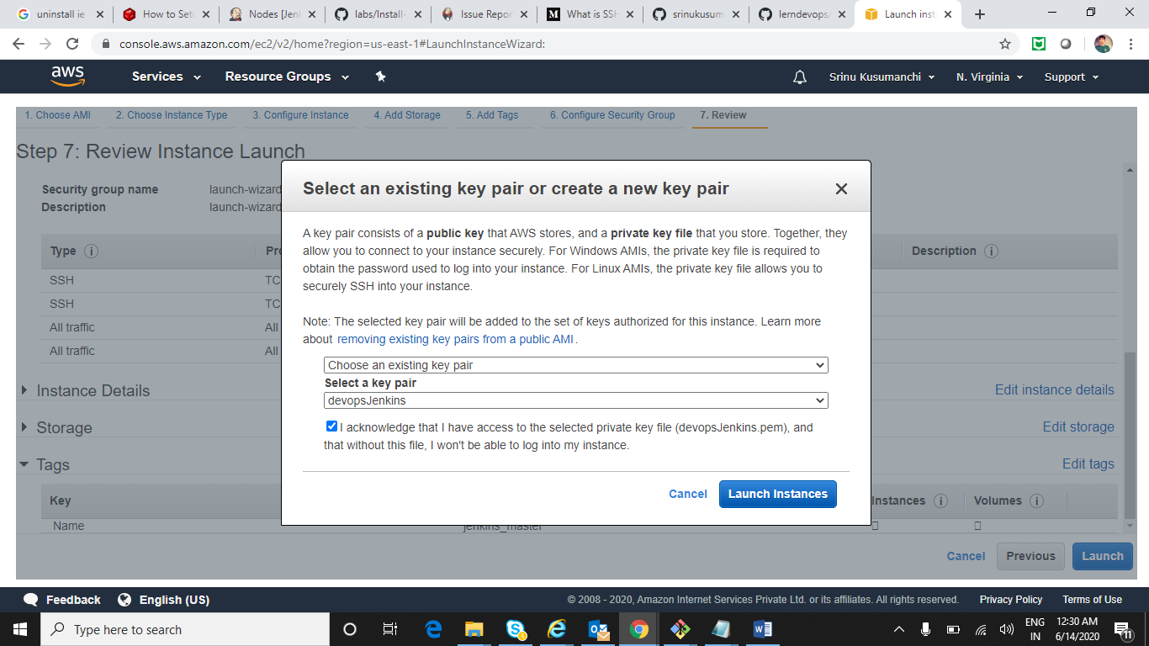

Instance is going to run successfully

